OBL Hackathon NPL Insights:

Out of all the tile varieties available, lighter shades are the ones selling well. White Shades to be exact. North Region showing highest value – quantity tradeoff with 13Kmillion worth sales by value. Aditya Ceramics from Bihar and KSR Ceramics from Karnataka being top players for the sales. Most sales have been through the retail type sales by the companies. Every year the month of March seems to show higher sales as compared to other months.

Performance centric tiles like anti skid, plank, slate and so on are widely being used in the southern parts of the india. PGVT travertino marble is the most preferred type of the mable tiles and it is most prevailently used in the east and the southern parts of the india. Aesthetic centric tiles like the floral and white ivory are being widely used by the northern part of the india.

Granite tiles are being highly sold in Karnataka which is also one of the highest producer of the same ( can also be because of the recent IT boom in banglore where the offices and malls might use more granites as granites are costlier than usual tiles). Firozabad has been the lead glass manufacturer for centuries (Firozabad is near new delhi)

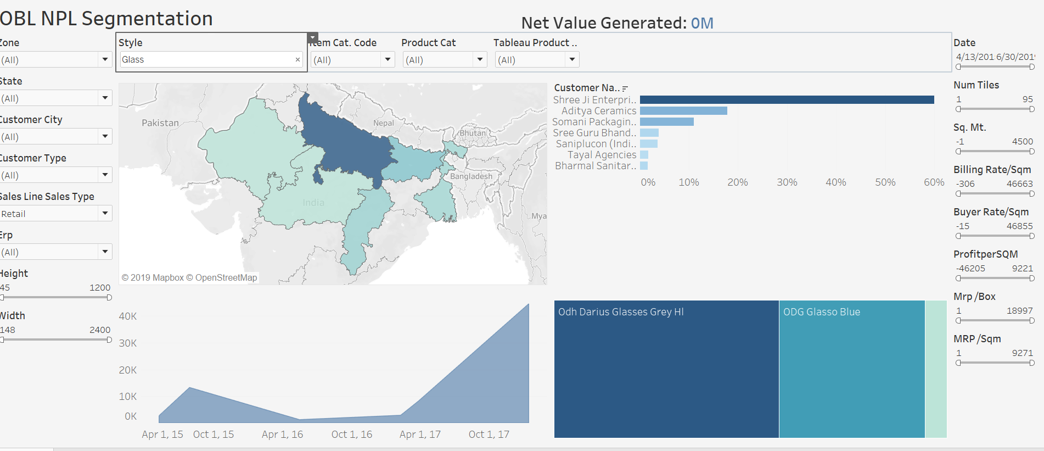

So no doubt the locals have been more used to the local market influence when it comes to glass tiles.

The biggest drawback to cement tiles is that they’re a beast to lay. Additionally, cement tile must be resealed once a month to maintain its beauty. Cement is best used in low-traffic areas and in small quantities.

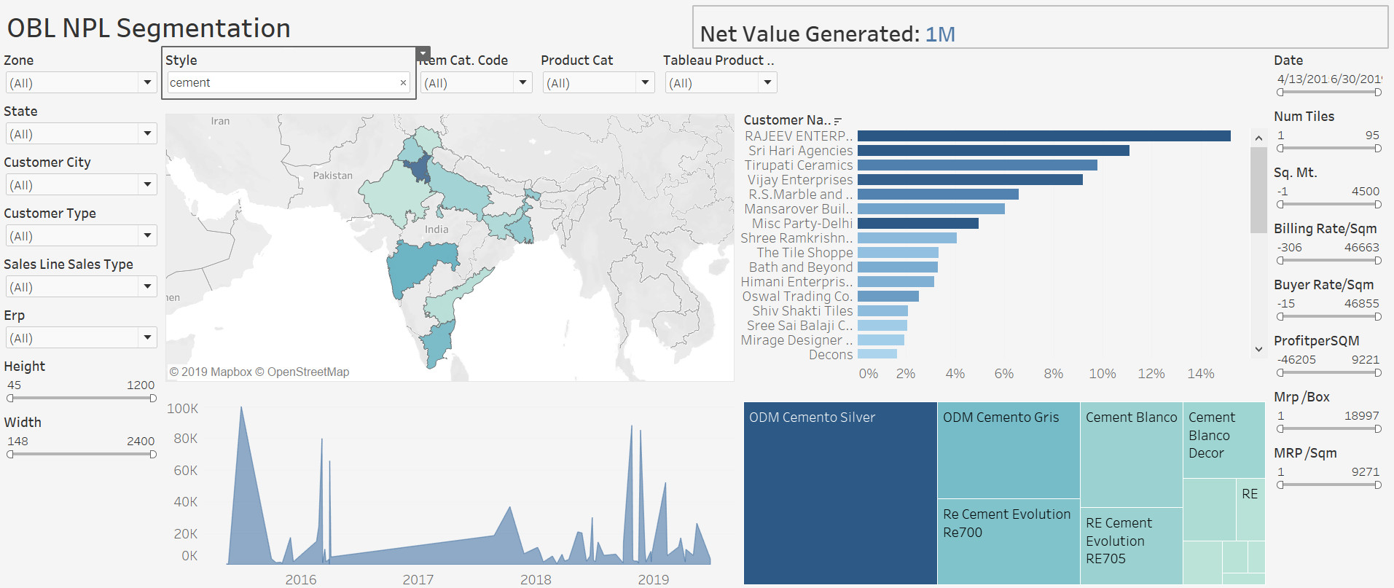

That is the reason they show on and off on trends then and there.

People are starting to move with the trend. Metal tiles are widely being used in places where more modern looks are preferred in places where the IT boom has taken place in Karnataka and TN.

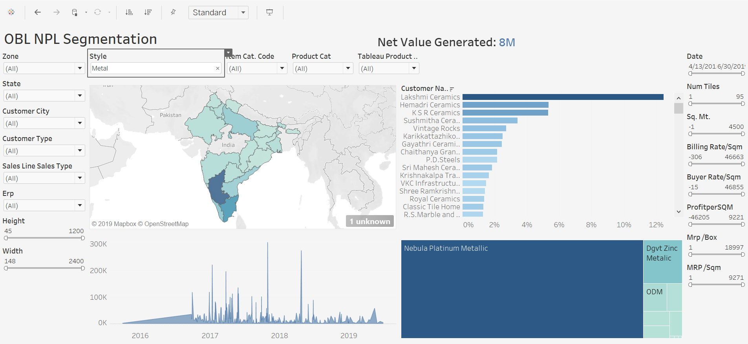

Travertine tiles

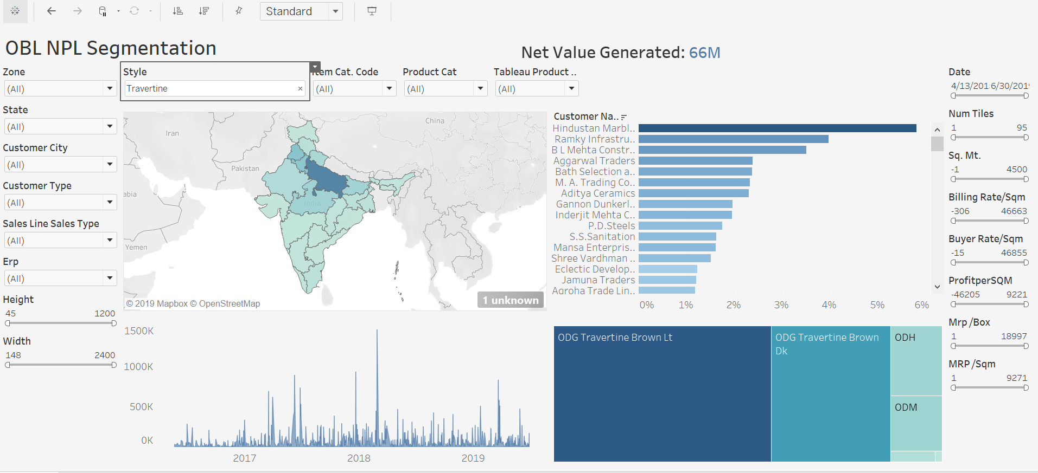

These are Porsche tiles having high aesthetic value being sold by Hindustan Marbles a lot they are used a lot in north (Delhi and UP) and east india.